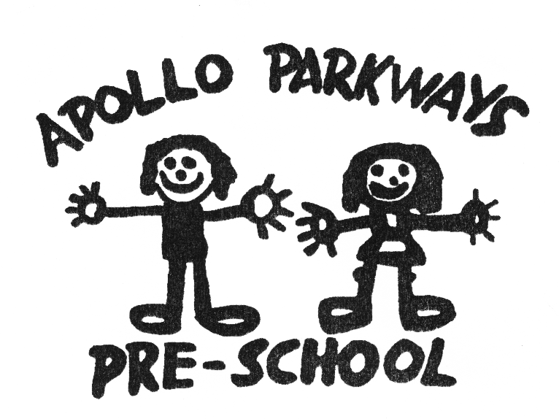

Determining Responsible Person Policy
Mandatory – Quality Area 4

PURPOSE
This policy will provide guidelines to assist in determining the Responsible Person at Apollo Parkways Pre-School.

Policy statement

Values
Apollo Parkways Pre-School is committed to:
- meeting its duty of care (refer to Definitions) obligations under the law
- ensuring staffing arrangements contribute to the health, safety, wellbeing, learning and development of all children at the service
- meeting legislative requirements for a Responsible Person to be on the service premises at all times.

Scope
This policy applies to the Approved Provider, Nominated Supervisor, Certified Supervisor, educators, staff, students on placement, volunteers and parents/guardians of Apollo Parkways Pre-School.

Background and legislation

Background
Under the Education and Care Services National Law Act 2010, it is an offence to operate an approved centre-based education and care service unless a Responsible Person is present.
Legislation requires that a Responsible Person is physically in attendance at all times the service is educating and caring for children. The Responsible Person is either the Approved Provider (or the person in management or control of the service), the Nominated Supervisor of the service, or a Certified Supervisor who has been placed in day-to-day charge of the service. For more information regarding these terms, refer to Definitions.
An Approved Provider must not operate a service unless there is a Nominated Supervisor appointed for that service. The Nominated Supervisor does not have to be in attendance at the service at all times, but in their absence, a person with a Supervisor Certificate (a Certified Supervisor) is to be placed in charge, ensuring there is always someone on the service premises who has been assessed as fit and proper by the Regulatory Authority. It is important to note that a Certified Supervisor placed in day-to-day charge of a service does not have the same responsibilities under the National Law as the Nominated Supervisor.

Legislation and standards
Relevant legislation and standards include but are not limited to:
- Education and Care Services National Law Act 2010: Sections 5, 44, 56, 106–109, 114, 115, 118, 161, 162, 172, 291(5)
- Education and Care Services National Regulations 2011: Regulations 35, 46–49, 146, 168(2)(i)(ii), 173, 176(2)(c)
- National Quality Standard, Quality Area 4: Staffing Arrangements
  - Standard 4.1: Staffing arrangements enhance children’s learning and development and ensure their safety and wellbeing
- National Quality Standard, Quality Area 7: Leadership and Service Management
  - Standard 7.1:Effective leadership promotes a positive organisational culture and builds a professional learning community
    - Element 7.1.5: Adults working with children and those engaged in management of the service or residing on the premises are fit and proper
- Working with Children Act 2005 (Vic)
- Working with Children Regulations 2006 (Vic)
The most current amendments to listed legislation can be found at:
- Victorian Legislation – Victorian Law Today: http://www.legislation.vic.gov.au/
- Commonwealth Legislation – ComLaw: http://www.comlaw.gov.au/

Definitions
The terms defined in this section relate specifically to this policy. For commonly used terms e.g. National Law, National Regulations, Regulatory Authority etc. refer to the General Definitions section of this manual.
Approved Provider: An individual or organisation that has completed an application and been approved by the Regulatory Authority as fit and proper (in accordance with Sections 12, 13 and 14 of the National Law) to operate one or more education and care services. Where the applicant is an organisation, each person with management and control of that organisation must complete a separate application form. (Note: Under the Education and Care Services National Law Act 2010, Section 5, Definitions: “person with management or control, in relation to an education and care service, means – (b) if the provider of the service is an eligible association, each member of the executive committee of the association who has the responsibility, alone or with others, for managing the delivery of the education and care service”.)
Approved service: An education and care service for which a service approval exists. A request for service approval must be made in writing to the Regulatory Authority and include prescribed information including details of the Nominated Supervisor and their written consent to be nominated as such.
Certified Supervisor: An educator with a Supervisor Certificate (in accordance with the National Regulations) who may consent to being placed in day-to-day charge of the education and care service. The designation must be made by the Approved Provider or the Nominated Supervisor and accepted in writing by the Certified Supervisor. A Certified Supervisor placed in day-to-day charge of a service does not have the same responsibilities under the National Law as the Nominated Supervisor. Applications for Supervisor Certificates are assessed by the Regulatory Authority.
Duty of care: A common law concept that refers to the responsibilities of organisations to provide people with an adequate level of protection against harm and all reasonable foreseeable risk of injury.
Fit and proper: In determining whether an applicant is fit and proper, the Regulatory Authority must take into account the applicant’s history of involvement in education and care services, their compliance with current and prior law, criminal history record check and any bankruptcy or insolvency issues. The Regulatory Authority may reassess fitness and propriety at any time. Applicants are required to complete the Declaration of Fitness and Propriety form on the ACECQA website and have this approved by the Regulatory Authority. This form must be completed by an individual provider applicant or in the case of an entity provider applicant, each person with management or control of a service. The form is available at: http://acecqa.gov.au/application-forms/provider-approvals/
(Note: Under the Education and Care Services National Law Act 2010, Section 5, Definitions: “person with management or control, in relation to an education and care service, means – (b) if the provider of the service is an eligible association, each member of the executive committee of the association who has the responsibility, alone or with others, for managing the delivery of the education and care service”.)

Nominated Supervisor: A person who is a Certified Supervisor and has been nominated by the Approved Provider of the service under Part 3 of the Act to be the Nominated Supervisor of that service, and who has consented to that nomination. The Nominated Supervisor has day-to-day responsibility for the service in accordance with the National Regulations. All services must have a Nominated Supervisor.
Supervisor Certificate: Allows a person to consent to be the Nominated Supervisor or Certified Supervisor, and be placed in day-to-day charge of an approved service. Applicants must be 18 years or older, be assessed as a fit-and-proper person (refer to Definitions above) and meet the minimum requirements for qualifications, experience and management capability required under the Regulations (Regulations 46–49). Applicants for a Supervisor Certificate are assessed by the Regulatory Authority.
Responsible Person: The Approved Provider (if that person is an individual, and in any other case the person with management or control of the service operated by the Approved Provider) or a Nominated Supervisor or Certified Supervisor who has been placed in day-to-day charge of the service in accordance with the National Regulations.

Sources and related policies

Sources
- Australian Children’s Education and Care Quality Authority (ACECQA), Information Sheets: http://www.acecqa.gov.au/national-quality-framework/information-sheets-new
- Guide to the Education and Care Services National Law and the Education and Care Services National Regulations 2011: www.acecqa.gov.au
- Guide to the National Quality Standard: www.acecqa.gov.au

Service policies
- Code of Conduct Policy
- Participation of Volunteers and Students Policy
- Privacy and Confidentiality Policy
- Staffing Policy
- Supervision of Children Policy

Procedures

The Approved Provider is responsible for:
- ensuring there is a Responsible Person (refer to Background and Definitions) on the premises at all times the service is delivering education and care programs for children
- ensuring that a person eligible to be nominated as a Responsible Person holds a Supervisor Certificate (refer to Definitions) and has appropriate skill level, experience, qualifications and approval to work with children, as required under the National Law and National Regulations
- ensuring that the name and position of the Responsible Person in charge of the service is displayed and easily visible from the main entrance of the service(National Law: Section 172)
- ensuring that the service does not operate without a Nominated Supervisor, and that this person has given written consent and holds a Supervisor Certificate (refer to Definitions)
- ensuring that the name of the Nominated Supervisor is displayed prominently at the service
- ensuring that information about the Nominated Supervisor, including name, address, date of birth, evidence of qualifications and approved training, and a Working with Children Check (refer to Staffing Policy) is kept on the staff record (Regulation 146)
- notifying the Regulatory Authority in writing if there is a change of person in the role of Nominated Supervisor (Section 56, Regulation 35)
- ensuring that, in the absence from the service premises of a Nominated Supervisor, another person with a Supervisor Certificate (a Certified Supervisor – refer to Definitions) is placed in day-to-day charge of the service
- ensuring that the Nominated Supervisor and Certified Supervisors have a sound understanding of the role of Responsible Person
- ensuring there are sufficient educators with Supervisor Certificates (refer to Definitions) to meet the legislative requirement for a Responsible Person at the service during periods of leave or illness
- ensuring details of Supervisor Certificates are recorded on the staff record
- notifying the Regulatory Authority in writing if there any changes to:
  - the name of the Approved Provider
  - the appointment or removal of a person with management or control of the service operated by the Approved Provider
  - the status of the Approved Provider as fit and proper
- notifying the Regulatory Authority if a Nominated Supervisor or Certified Supervisor has their Working with Children Check card or teacher registration suspended or cancelled, or if they are subject to any disciplinary proceedings under the law.

The Nominated Supervisor is responsible for:
- holding a Supervisor Certificate
- providing written consent to accept the role of Nominated Supervisor
- ensuring that, in their absence from the service premises, another person with a Supervisor Certificate (a Certified Supervisor – refer to Definitions) is placed in day-to-day charge of the service
- ensuring they have a sound understanding of the role of Responsible Person
- ensuring that the name and position of the Responsible Person in charge of the service is displayed and easily visible from the main entrance of the service
- developing rosters in accordance with the availability of Responsible Persons, hours of operations and the attendance patterns of children
- notifying the Approved Provider and the Regulatory Authority within 7 days of any changes to their personal situation, including a change in mailing address, circumstances that affect their status as fit and proper, such as the suspension or cancellation of a Working with Children Check card or teacher registration, or if they are subject to disciplinary proceedings
- notifying the Approved Provider if the Regulatory Authority cancels their Supervisor Certificate for any reason.

Certified Supervisors are responsible for:
- holding a Supervisor Certificate
- providing written consent to accept the role of Certified Supervisor
- checking that the name and position of the Responsible Person in charge of the service is displayed and easily visible from the main entrance of the service
- informing the Approved Provider and/or Nominated Supervisor in the event of absence from the service due to leave or illness so they can be replaced by another Responsible Person
- ensuring they have a sound understanding of the role of Responsible Person
- abiding by any conditions placed on the Supervisor Certificate
- understanding that a Certified Supervisor placed in day-to-day charge of an approved service does not have the same responsibilities under the National Law as the Nominated Supervisor
- notifying the Approved Provider and the Regulatory Authority within 7 days of any changes to their personal situation, including a change in mailing address, circumstances that affect their status as fit and proper, such as the suspension or cancellation of a Working with Children Check card or teacher registration, or if they are subject to disciplinary proceedings
- notifying the Approved Provider if the Regulatory Authority cancels their Supervisor Certificate for any reason.

Educators are responsible for:
- meeting the qualifications, experience and management requirements if they wish to gain a Supervisor Certificate, as defined in the National Regulations (Regulations 46–49)
- applying to the Regulatory Authority and obtaining a Supervisor Certificate if they wish to accept nomination as a Certified Supervisor
- ensuring they have a sound understanding of the role of Responsible Person
- providing written consent if accepting the nomination to be a Certified Supervisor.

Parents/guardians are responsible for:
- reading and understanding this policy
- being aware of the Responsible Person at the service on a daily basis.

Volunteers and students, while at the service, are responsible for following this policy and its procedures.

Evaluation
In order to assess whether the values and purposes of the policy have been achieved, the Approved Provider will:
- regularly seek feedback from everyone affected by the policy regarding its effectiveness
- monitor the implementation, compliance, complaints and incidents in relation to this policy
- keep the policy up to date with current legislation, research, policy and best practice
- revise the policy and procedures as part of the service’s policy review cycle, or as required
- notify parents/guardians at least 14 days before making any changes to this policy or its procedures.

Attachments
Nil

Authorisation
This policy was adopted by the Approved Provider of Apollo Parkways Pre-School on 16th May 2016

Review date: May 2019

The guidelines to the National Regulations state that, given the Responsible Person in charge may change throughout the day (for example, at a changeover of shifts), this requirement might be met on a whiteboard or interchangeable name plate at the entrance of the service premises.

