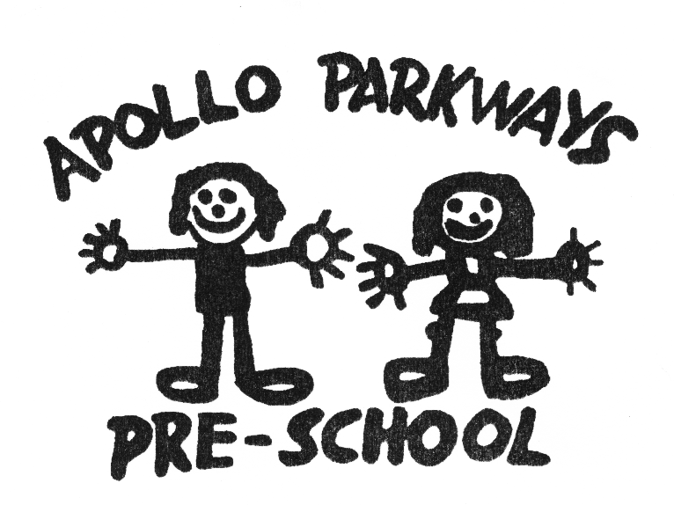

Governance and Management of the Service Policy
Mandatory – Quality Area 7

Purpose
This policy outlines the duties, roles and responsibilities of the Committee of Management of Apollo Parkways Pre-School.

Policy statement

Values
Apollo Parkways Pre-School is committed to ensuring that there are appropriate systems and processes in place to enable:
- good governance and management of the organisation
- accountability to its stakeholders
- compliance with all regulatory and legislative requirements placed on the organisation
- the organisation to remain solvent and comply with all its financial obligations.

Scope
This policy applies to the Approved Provider, the Committee of Management of Apollo Parkways Pre-School and all subcommittees of the Committee of Management.

Background and legislation

Background
The governance of an organisation is concerned with the systems and processes that ensure the overall direction, effectiveness, supervision and accountability of a service. Members of the Committee of Management are responsible for setting the directions for the service and ensuring that its goals and objectives are met in line with its constitution, and all legal and regulatory requirements governing the operation of the business are met.
Under the National Law and National Regulations, early childhood services are required to have policies and procedures in place relating to the governance and management of the service, including confidentiality of records (refer to Privacy and Confidentiality Policy).

Legislation and standards
Relevant legislation and standards include but are not limited to:
- Associations Incorporation Reform Act 2012 (Vic), as applicable to the service
- Corporations Act 2001, as applicable to the service
- Education and Care Services National Law Act 2010
- Education and Care Services National Regulations 2011: Regulation 168(2)(l)
- National Quality Standard, Quality Area 7: Leadership and Service Management
- Standard 7.3: Administrative systems enable the effective management of a quality service
The most current amendments to listed legislation can be found at:
- Victorian Legislation – Victorian Law Today: http://www.legislation.vic.gov.au/
- Commonwealth Legislation – ComLaw: http://www.comlaw.gov.au/

Definitions
The terms defined in this section relate specifically to this policy. For commonly used terms e.g. Approved Provider, Nominated Supervisor, Regulatory Authority etc. refer to the General Definitions section of this manual.
Actual conflict of interest: One where there is a real conflict between a Committee of Management member’s responsibilities and their private interests.
Conflict of interest: An interest that may affect, or may appear reasonably likely to affect, the judgement or conduct of a member (or members) of the Committee of Management or subcommittee, or may impair their independence or loyalty to the service. A conflict of interest can arise from avoiding personal losses as well as gaining personal advantage, whether financial or otherwise, and may not only involve the member of the Committee of Management or subcommittee, but also their relatives, friends or business associates.
Ethical practice: A standard of behaviour that the service deems acceptable in providing their services.
Governance: The process by which organisations are directed, controlled and held to account. It encompasses authority, accountability, stewardship, leadership, directions and control exercised in the organisation (Australian National Audit Office, 1999).
Interest: Anything that can have an impact on an individual or a group.
Perceived conflict of interest: Arises where a third party could form the view that a Committee of Management member’s private interests could improperly influence the performance of their duties on the Committee of Management, now or in the future.
Potential conflict of interest: Arises where a Committee of Management member has private interests that could conflict with their responsibilities.
Private interests: Includes not only a Committee of Management member’s own personal, professional or business interests, but also those of their relatives, friends or business associates.

Sources and related policies

Sources
- ELAA Early Childhood Management Manual, Version 2 2013
- Our Community: www.ourcommunity.com.au
- Justice Connect: http://www.justiceconnect.org.au/

Service policies
- Code of Conduct Policy
- Complaints and Grievances Policy
- Privacy and Confidentiality Policy

Procedures

The Approved Provider is responsible for:
- ensuring that the service has appropriate systems and policies in place for the effective governance and management of the service.

Core elements of the governance model
The following are the core elements of the governance systems at Apollo Parkways Pre-School for which the Committee of Management is responsible:

Stewardship/custodianship
Ensure:
- the service pursues its stated purpose and remains viable
- budget and financial accountability to enable ongoing viability and making best use of the service’s resources
- the service manages risks appropriately.

Leadership, forward planning and guidance
Provide leadership, forward planning and guidance to the service, particularly in relation to developing a strategic culture and directions.

Authority, accountability, and control
- Monitor and oversee management including ensuring that good management practices and appropriate checks and balances are in place.
- Be accountable to members of the service.
- Maintain focus, integrity and quality of service.
- Oversee legal functions and responsibilities.
- Declare any actual, potential or perceived conflicts of interest (refer to Definitions and Attachment 1 – Sample Conflict of interest disclosure statement).

Legal liabilities of members of the Committee of Management
The Committee of Management at Apollo Parkways Pre-School is responsible under the constitution to take all reasonable steps to ensure that the laws and regulations relating to the operation of the service are observed. Members of the Committee of Management are responsible for ensuring that:
- adequate policies and procedures are in place to comply with the legislative and regulatory requirements placed on the service
- appropriate systems are in place to monitor compliance
- reasonable care and skill is exercised in fulfilling their roles as part of the governing body of the service
- they act honestly, and with due care and diligence
- they do not use information they have access to, by virtue of being on the Committee of Management improperly
- they do not use their position on the Committee of Management for personal gain or put individual interests ahead of responsibilities.

Responsibilities of the Committee of Management
The Committee of Management of Apollo Parkways Pre-School is responsible for:
- developing coherent aims and goals that reflect the interests, values and beliefs of the members and staff, and the stated aims of the service, and have a clear and agreed philosophy which guides business decisions and the work of the Committee of Management and staff
- ensuring there is a sound framework of policies and procedures that complies with all legislative and regulatory requirements, and that enables the daily operation of the service to be geared towards the achievement of the service’s vision and mission
- establishing clearly defined roles and responsibilities for the members of the Committee of Management, individually and as a collective, management and staff, and clearly articulate the relationship between the Committee of Management, staff and members of the service
- developing ethical standards and a code of conduct (refer to Code of Conduct Policy) which guide actions and decisions in a way that is transparent and consistent with the goals, values and beliefs of the service
- undertaking strategic planning and risk assessment on a regular basis and having appropriate risk management strategies in place to manage risks faced by the service
- ensuring that the actions of and decisions made by the Committee of Management are transparent and will help build confidence among members and stakeholders
- reviewing the service’s budget and monitoring financial performance and management to ensure the service is solvent at all times, and has good financial strength
- approving annual financial statements and providing required reports to government
- setting and maintaining appropriate delegations and internal controls
- appointing senior staff (e.g. the CEO or Director, if the service is large) or all staff (if the service is small), and monitoring their performance
- evaluating and improving the performance of the Committee of Management
- focusing on the strategic directions of the organisation and avoiding involvement in day-to-day operational decisions, particularly where the authority is delegated to senior management staff within the service.

Confidentiality
All members of the Committee of Management and subcommittees who gain access to confidential, commercially-sensitive and other information of a similar nature, whether in the course of their work or otherwise, shall not disclose that information to anyone unless the disclosure of such information is required by law (refer to Privacy and Confidentiality Policy).
Members of the Committee of Management and subcommittees shall respect the confidentiality of those documents and deliberations at Committee of Management or subcommittee meetings, and shall not:
- disclose to anyone the confidential information acquired by virtue of their position on the Committee of Management or subcommittee
- use any information so acquired for their personal or financial benefit, or for the benefit of any other person
- permit any unauthorised person to inspect, or have access to, any confidential documents or other information.
This obligation, placed on a member of the Committee of Management or subcommittee, shall continue even after the individual has completed their term and is no longer on the Committee of Management or subcommittee.
The obligation to maintain confidentiality also applies to any person who is invited to any meetings of the Committee of Management or subcommittee as an observer or in any other capacity.

Ethical practice
The following principles will provide the ethical framework to guide the delivery of services at Apollo Parkways Pre-School:
- treating colleagues, parents/guardians, children, suppliers, public and other stakeholders respectfully and professionally at all times
- dealing courteously with those who hold differing opinions
- respecting cultural differences and diversity within the service, and making every effort to encourage and include all children and families in the community
- having an open and transparent relationship with government, supporters and other funders
- operating with honesty and integrity in all work
- being open and transparent in making decisions and undertaking activities, and if that is not possible, explaining why
- working to the standards set under the National Quality Framework and all applicable legislation as a minimum, and striving to continually improve the quality of the services delivered to the community
- disclosing conflicts of interest as soon as they arise and effectively managing them (refer to Attachment 1 – Sample Conflict of interest disclosure statement)
- recognising the support and operational contributions of others in an appropriate manner
- assessing and minimising the adverse impacts of decisions and activities on the natural environment.

Managing conflicts of interest
Conflicts of interest, whether actual, potential or perceived (refer to Definitions), must be declared by all members of the Committee of Management or subcommittee, and managed effectively to ensure integrity and transparency (refer to Attachment 1 – Sample Conflict of interest disclosure statement).
Every member of the Committee of Management or subcommittee has a continuing responsibility to scrutinise their transactions, external business interests and relationships for potential conflicts and to make such disclosures in a timely manner as they arise.
The following process will be followed to manage any conflicts of interest:
- whenever there is a conflict of interest, as defined in this policy, the member concerned must notify the President of such conflict, as soon as possible after identifying the conflict
- the member who is conflicted must not be present during the meeting of the Committee of Management or subcommittee where the matter is being discussed, or participate in any decisions made on that matter. The member concerned must provide the Board or committee with any and all relevant information they possess on the particular matter
- the minutes of the meeting must reflect that the conflict of interest was disclosed and appropriate processes followed to manage the conflict.
A Conflict of interest disclosure statement (refer to Attachment 1) must be completed by each member of the Committee of Management and subcommittee upon his or her appointment and annually thereafter. If the information in this statement changes during the year, the member shall disclose the change to the President, and revise the disclosure statement accordingly.
All violations of the requirement to disclose and manage conflicts shall be dealt with in accordance with the constitution of Apollo Parkways Pre-School.

Evaluation
In order to assess whether the values and purposes of the policy have been achieved, the Committee of Management will:
- regularly seek feedback from everyone affected by the policy regarding its effectiveness
- monitor the implementation, compliance, complaints and incidents in relation to this policy
- keep the policy up to date with current legislation, research, policy and best practice
- revise the policy and procedures as part of the service’s policy review cycle, or as required
- notify parents/guardians at least 14 days before making any changes to this policy or its procedures.

Attachments
- Attachment 1: Sample Conflict of interest disclosure statement

Authorisation
This policy was adopted by the Approved Provider of Apollo Parkways Pre-School on 16th May 2016

Review date: May 2019
Attachment 1
Sample Conflict of interest disclosure statement
Name (in full):

Postal address:

Position on Committee of Management or subcommittee

Declaration:
I hereby declare the following conflict of interest: (Note: tick all applicable boxes)

ACTUAL POTENTIAL PERCEIVED

Please provide a brief outline of the nature of the conflict (details may be included in a separate confidential envelope, if appropriate).

Please detail the arrangements proposed to resolve/manage the conflict (details may be included in a separate confidential envelope, if appropriate).

I, (insert name in full) hereby agree to:
- update this disclosure throughout the period of my tenure on the Committee of Management or subcommittee of Apollo Parkways Pre-School.
- co-operate in the formulation of a Conflict of interest management plan, as required.
- comply with any conditions or restrictions imposed by the Committee of Management or subcommittee to manage, mitigate or eliminate any actual, potential or perceived conflict of interest.

Signed Date

Also known in some services as Board of Directors or Board of Management etc.

