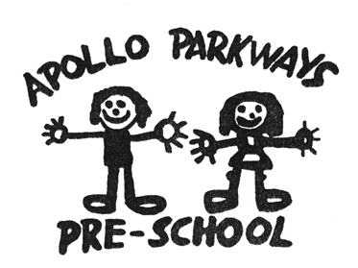

Hygiene Policy
Best Practice – Quality Area 2

Purpose
This policy will provide guidelines for procedures to be implemented at [Service Name] to ensure:
- effective and up-to-date control of the spread of infection
- the provision of an environment that is safe, clean and hygienic.

Policy statement

Values
Apollo Parkways Pre-School is committed to protecting all persons from disease and illness by minimising the potential for infection through:
- implementing and following effective hygiene practices
- implementing infection control procedures to minimise the likelihood of cross-infection and the spread of infectious diseases and illnesses to children, staff and any other persons in attendance at the service
- fulfilling the service’s duty of care requirement under the Occupational Health and Safety Act 2004, the Education and Care Services National Law Act 2010 and the Education and Care Services National Regulations 2011 to ensure that those involved with the service are protected from harm
- informing educators, staff, volunteers, children and families about the importance of adhering to the Hygiene Policy to maintain a safe environment for all users, and communicating the shared responsibility between all involved in the operation of the service.

Scope
This policy applies to the Approved Provider, Nominated Supervisor, Certified Supervisor, educators, staff, students on placement, volunteers, parents/guardians, children and others attending the programs and activities of Apollo Parkways Pre-School, including during excursions and offsite activities.

Background and legislation

Background
Infections are common in children and often lead to illness. A person with an infection may or may not show signs of illness and, in many instances, the infectious phase of the illness may be in the period before symptoms become apparent, or during the recovery phase. While it is not possible to prevent all infections in education and care environments, services can prevent or control the spread of many infectious diseases by adopting simple hygiene practices.
An infection can be spread when an infected person attends the service premises and contamination occurs. A service can contribute to the spread of an infection through poor hygiene practices that allow infectious organisms to survive or thrive in the service environment.
The implementation of appropriate hygiene and infection control procedures aims to break the cycle and prevent the spread of infections at every stage. The National Health and Medical Research Council (NHMRC) suggest that to reduce illness in education and care services, the three most effective methods of infection control are:
- effective hand washing
- exclusion of sick children, staff and visitors
- immunisation.

Other strategies to prevent infection include:
- cough etiquette
- appropriate use of gloves
- effective cleaning of the service environment.
The NHMRC suggests that if these strategies are not implemented, all other procedures described in the service’s Hygiene Policy will have reduced effectiveness in preventing the spread of infection and illness.

Legislation and standards
Relevant legislation and standards include but are not limited to:
- Education and Care Services National Law Act 2010
- Education and Care Services National Regulations 2011: Regulations 77, 106, 109, 112, 168
- Food Act 1990
- National Quality Standard, Quality Area 2: Children’s Health and Safety
  - Standard 2.1: Each child’s health is promoted
    - Element 2.1.3: Effective hygiene practices are promoted and implemented
    - Element 2.1.4: Steps are taken to control the spread of infectious diseases and to manage injuries and illness, in accordance with recognised guidelines
- Occupational Health and Safety Act 2004
- Public Health and Wellbeing Act 2008
The most current amendments to listed legislation can be found at:
- Victorian Legislation – Victorian Law Today: http://www.legislation.vic.gov.au/
- Commonwealth Legislation – ComLaw: http://www.comlaw.gov.au/

Definitions
The terms defined in this section relate specifically to this policy. For commonly used terms e.g. Approved Provider, Nominated Supervisor, Regulatory Authority etc. refer to the General Definitions section.
Cleaning: A process that removes visible contamination such as food waste, dirt and grease from a surface. This process is usually achieved by the use of water and detergent. During this process, micro-organisms will be removed but not destroyed.
Communicable disease: A disease capable of being transmitted from an infected person or species to a susceptible host, either directly or indirectly.
Cough etiquette: The correct way to prevent the spread of infectious organisms that are carried in droplets of saliva is to cough or sneeze into the inner elbow or to use a tissue to cover the mouth and nose. Place all tissues in the rubbish bin immediately and clean hands with either soap and water or a disinfectant hand rub.
Hygiene: The principle of maintaining health and the practices put in place to achieve this.
Infectious disease: A disease that can be spread, for example, by air, water or interpersonal contact. An infectious disease is designated under Victorian Law or by a health authority (however described) as a disease that would require the infected person to be excluded from an education and care service (refer to Dealing with Infectious Diseases Policy).
Neutral detergent: A cleaning agent available commercially and labelled as ‘neutral’ or ‘neutral pH’.
Sanitising: A process that destroys micro-organisms. Sanitising a surface can reduce the number of micro-organisms present. The process of sanitisation usually involves ensuring a surface is thoroughly cleaned with both heat and water, followed by the use of chemicals.

Sources and related policies

Sources
- Department of Health, Victoria, Food Safety: http://www.health.vic.gov.au/foodsafety/
- Communicable Diseases Section, Public Health Group, Victorian Department of Human Services (2005) The Blue Book: Guidelines for the control of infectious diseases. Available at: http://docs.health.vic.gov.au/docs/doc/The-blue-book
- National Health and Medical Research Council (2013) Staying Healthy: Preventing infectious diseases in early childhood education and care services (5th edition): http://www.nhmrc.gov.au/guidelines/publications/ch55

Service policies
- Administration of First Aid Policy
- Administration of Medication Policy
- Dealing with Infectious Diseases Policy
- Dealing with Medical Conditions Policy
- Incident, Injury, Trauma and Illness Policy
- Occupational Health and Safety Policy
- Privacy and Confidentiality Policy

Procedures

The Approved Provider is responsible for:
- ensuring that all staff and volunteers are provided with a copy of this policy and have a clear understanding of the procedures and practices outlined within
- ensuring the Nominated Supervisor, educators, staff and volunteers at the service implement adequate health and hygiene practices, and safe practices for handling, preparing and storing food (Regulation 77(1))
- establishing robust induction procedures that include the provision of information regarding the implementation of the practices outlined in this policy
- developing an appropriate cleaning and sanitising schedule that outlines daily, weekly, monthly, quarterly and annual cleaning and sanitising requirements and responsibilities
- arranging for the service to be cleaned and sanitised regularly, including floors and other surfaces, as per the cleaning contract and schedule
- reviewing the cleaner’s contract and schedule on an annual basis
- contacting the local council’s Environmental Health Officer for information about obtaining a needle/syringe/sharps disposal unit and instructions for its use
- ensuring the service has laundry facilities or access to laundry facilities, or other arrangements for dealing with soiled clothing, nappies and linen, including hygienic facilities for storage prior to their disposal or laundering (Regulation 106(1))
- ensuring that the laundry and hygiene facilities are located and maintained in a way that does not pose a risk to children (Regulation 106(2))
- ensuring that there are adequate and appropriate hygiene facilities provided for nappy changing which are designed, located and maintained in such a way that prevents unsupervised access by children (Regulations 112(2)&(4))
- ensuring that adequate, developmental and age-appropriate toilet, washing and drying facilities are provided for use by children, and that these are safe and accessible (Regulation 109)
reviewing staff training needs in relation to understanding and implementing effective hygiene practices in early childhood settings
- providing a copy of the NHMRC guidelines for the prevention of infectious diseases in child care for the service
- providing hand washing guidelines for display at each hand washing location
- ensuring there is an adequate supply of non-toxic cleaning and hygiene products, including gloves, at all times.

The Nominated Supervisor is responsible for:
- implementing and ensuring that all staff members and volunteers at the service follow adequate health and hygiene practices, and safe practices for preparing, handling and storing food to minimise risks to children (Regulation 77(2))
- developing effective hygienic systems for cleaning, such as using colour-coded sponges/cloths in each area
- ensuring sponges are cleaned, rinsed and stored separately, and replaced regularly
- ensuring that an inspection of the outdoor areas, in particular the sand and soft-fall areas, are conducted daily to ensure they are maintained in a safe and hygienic manner
- informing the Approved Provider of any issues that impact on the implementation of this policy
- actively encouraging parents/guardians to keep children who are unwell at home to prevent the spread of infection to other children and educators
- storing or presenting items, such as beds, bedding and sunhats, in such a way as to prevent
cross-contamination
- ensuring that there is a regular and thorough cleaning and disinfecting schedule for all equipment and toys
- ensuring any chemicals and cleaning agents are non-toxic and stored out of reach of children
- ensuring that all educators/staff wear disposable gloves when changing nappies or dealing with open wounds or other body fluids, and dispose of those gloves and soiled materials in a sealed container or plastic bag
- maintaining the service in a clean and hygienic manner throughout the day, such as wiping benches and tables before and after eating, and cleaning up spills
- actively encouraging educators and staff who have, or are suspected of having an infectious disease to not attend the service in order to prevent the spread of infection to others attending the service.

Certified Supervisors and other educators are responsible for:
- implementing and promoting correct hand washing and hygiene practices, as outlined in this policy
- maintaining the service in a clean and hygienic manner throughout the day, such as wiping benches and tables before and after eating, and cleaning up spills
- conducting a daily inspection of the outdoor areas, in particular the sand and soft-fall areas, to ensure they are maintained in a safe and hygienic manner
- informing the Approved Provider of any issues that impact on the implementation of this policy
- actively encouraging parents/guardians to keep children who are unwell at home to prevent the spread of infection to other children and educators
- being conscious of their responsibility to not attend the service when they have or suspect they have an infectious disease.
In relation to changing nappies for children:
- attending to the individual personal hygiene needs of each child as soon as is practicable
- changing nappies and attending to individual personal hygiene and toileting needs of each child according to recommended procedures (refer to Attachment 1 – Sample nappy-changing and toileting guidelines)
- disposing of soiled nappies in a safe and hygienic manner in line with this policy.
In relation to the toileting of children:
- ensuring soap and drying facilities are available at all times when children are in attendance at the service, including ensuring paper towels are available if hand-dryers are not working
- ensuring children do not share the use of items related to personal care, such as hand towels for drying hands, toothbrushes and hairbrushes
- encouraging children to flush the toilet after use
- encouraging and assisting (where required) children to wash their hands according to hand washing guidelines (refer to Attachment 2) after toileting
- encouraging children to tell a staff member if they have had a toileting accident
- monitoring and maintaining toileting facilities in a safe, clean and hygienic manner while children are in attendance; this requires periodic checking of the bathroom area
- respecting diverse styles of toileting children due to cultural or religious practices
- respecting the possible need to maintain privacy of toileting and dressing.
In relation to cleaning toys, clothing and the service in general:
- removing toys that a child has sneezed or coughed on (place in a ‘toys-to-be-cleaned’ box)
- wearing gloves when cleaning (general purpose gloves are sufficient; wash and hang outside to dry when finished)
- washing mouthed toys daily using warm water and detergent and, if possible, drying in the sun
- wiping over books with a moist cloth treated with detergent
- ensuring washable toys and equipment are cleaned term by term or annually, as required
- washing and disinfecting mattress covers and linen, where applicable.
In relation to children’s contact with one another:
- educating and encouraging children in good personal hygiene practices, such as:
    - washing their hands after blowing and wiping their nose
    - not touching one another when they are cut or bleeding
    - disposing of used tissues promptly and appropriately, and not lending them to other children
    - using their own equipment for personal care, such as toothbrushes, hats, brushes and combs
    - only touching the food they are going to eat
    - using their own drink bottles or cups.
In relation to indoor and outdoor environments:
- keeping the indoor and outdoor environments as clean and hygienic as possible at all times, including the safe disposal of discarded needles/syringes/sharps
- promptly removing blood, urine and faeces (including animal) either indoors or outdoors, using the appropriate cleaning procedures
- covering the sandpit when not in use to prevent contamination
- emptying water containers, such as water trays, each day (refer to Water Safety Policy)
- disposing of any dead animals/insects found on the premises in an appropriate manner.
In relation to the safe handling of body fluids or materials in contact with body fluids:
- avoid direct contact with blood or other fluids
- not be at eye level when cleaning/treating a child’s face that has blood on it, as a child’s blood can enter the mouth/nose of a staff member when a child cries or coughs
- wear gloves wherever possible
- cover any cuts/abrasions on their own hands with a waterproof dressing.
In relation to effective environmental cleaning:
- clean with detergent and warm water followed by rinsing and drying to remove the bulk of infectious organisms from a surface. Particular attention should be paid to the following:
  - toilets/sinks must be cleaned daily and separate cleaning cloths/sponges must be used for each task
  - mouthed toys must be washed immediately or placed in a separate container for washing at a later time
  - all bench tops and floors must be washed regularly
  - children’s cups/drink bottles used for water must be washed daily
  - when washing at the child care premises, staff are to consider washing items separately to minimise cross-contamination, for example, tea towels washed separately from sheets, face washers washed separately to play mats/rugs
  - nappy change areas/mats must be washed with detergent and warm water after each use.

Parents/guardians are responsible for:
- keeping their child/ren home if they are unwell or have an infectious disease that requires their exclusion from the education and care service
- informing the service if their child has an infectious disease
- supporting this policy by complying with the hygiene practices when attending the service or when assisting with a service program or activity
- encouraging their child/ren to develop and follow effective hygiene practices at all times, including handwashing on arrival at the service.

Volunteers and students, while at the service, are responsible for following this policy and its procedures.

Evaluation
In order to assess whether the values and purposes of the policy have been achieved, the Approved Provider will:
- regularly seek feedback from everyone affected by the policy regarding its effectiveness
- monitor the implementation, compliance, complaints and incidents in relation to this policy and ensure satisfactory resolutions have been achieved
- keep the policy up to date with current legislation, research, policy and best practice
- revise the policy and procedures as part of the service’s policy review cycle, or as required
- notify parents/guardians at least 14 days before making any changes to this policy or its procedures.

Attachments
- Attachment 1: Nappy change procedure
- Attachment 2: Handwashing guidelines

Authorisation
This policy was adopted by the Approved Provider of Apollo Parkways Pre-School on 18 May 2018.

Review date: 18 MAY 2021
Attachment 1
Nappy change procedure
Download and attach the poster: Changing a nappy without spreading germs from the website of the National Health and Medical Research Council (2013) Staying Healthy: Preventing infectious diseases in early childhood education and care services (5th edition): http://www.nhmrc.gov.au/guidelines/publications/ch55
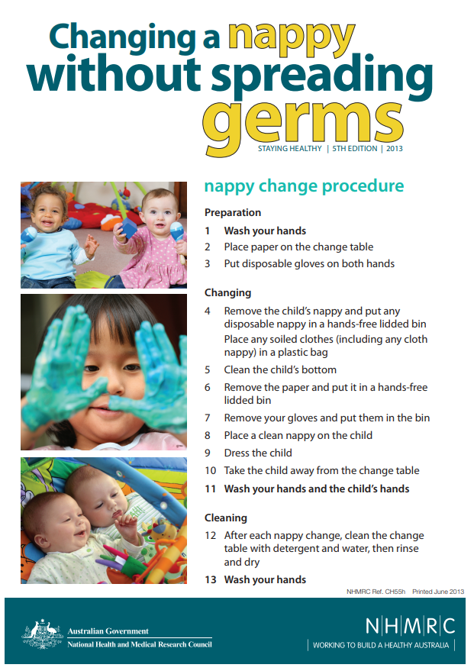
Attachment 2
Handwashing guidelines
Download and attach the poster: How to wash hands from the website of the National Health and Medical Research Council (2013) Staying Healthy: Preventing infectious diseases in early childhood education and care services (5th edition):
http://www.nhmrc.gov.au/guidelines/publications/ch55

