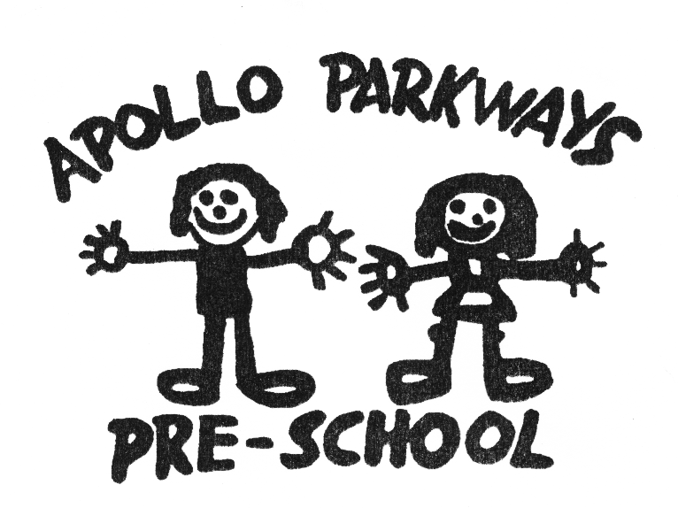

Acceptance and Refusal of Authorisations Policy
Mandatory – Quality Area 2

Purpose
This policy outlines procedures to be followed when:
- obtaining written authorisation from a parent/guardian or person authorised and named in the enrolment record
- refusing written authorisation from a parent/guardian or person authorised and named in the enrolment record.

Policy statement

Values
Apollo Parkways Pre-School is committed to:
- ensuring the safety and wellbeing of all children attending the service
- meeting its duty of care obligations under the law.

SCOPE
This policy applies to the Approved Provider, Nominated Supervisor, Certified Supervisor, educators, staff, students on placement, volunteers, parents/guardians, children and others attending the programs and activities of Apollo Parkways Pre-School.

Background and legislation

Background
Under the National Law and Regulations, early childhood services are required to obtain written authorisation from parents/guardians, and/or authorised nominees (refer to Definitions) in some circumstances, to ensure that the health, safety, wellbeing and best interests of the child are met. These circumstances include but are not limited to:
- self-administration of medication (Regulation 96)
- children leaving the service premises (Regulation 99)
- children being taken on excursions (Regulation 102).
Specific service policies (including the Administration of Medication Policy, Delivery and Collection of Children Policy, Enrolment and Orientation Policy and Excursions and Service Events Policy) should include details of the conditions under which written authorisations will be accepted. However, there may be instances when a service refuses to accept a written authorisation. The Education and Care Services National Regulations 2011 (Regulation 168(2)(m)) specify that services are required to develop a policy in relation to the acceptance and refusal of authorisations to help educators/staff and parents/guardians understand exactly what they need to do.
This policy outlines procedures to be followed when refusing a written authorisation from a parent/guardian or person authorised and named in the enrolment record. As an example, the National Law does not specify the minimum age of a person who is authorised to collect a child from the service premises. After consulting with parents/guardians and families, the Approved Provider may adopt a policy position accepting authorisations for persons over the age of 16 to collect a child from the service. This decision will then be outlined in the service’s Delivery and Collection of Children Policy. In the event that the service receives written authorisation for a person under the age specified in its Delivery and Collection of Children Policy, to collect a child from the service, the procedures outlined below for refusing this written authorisation would be enacted.

Legislation and standards
Relevant legislation and standards include but are not limited to:
- Children, Youth and Families Act 2005 (Vic) Child Wellbeing and Safety Act 2005 (Vic)
- Child Wellbeing and Safety Act 2005 (Vic) (Part 2: Principles for Children)
- Education and Care Services National Law Act 2010: Section 167
- Education and Care Services National Regulations 2011: Regulations 96, 99, 102, 160, 161, 168(2)(m), 170
- Family Law Act 1975 (Cth)
- National Quality Standard, Quality Area 2: Children’s Health and Safety
  - Standard 2.3: Each child is protected.
The most current amendments to listed legislation can be found at:
- Victorian Legislation – Victorian Law Today: http://www.legislation.vic.gov.au/
- Commonwealth Legislation – ComLaw: http://www.comlaw.gov.au/

Definitions
The terms defined in this section relate specifically to this policy. For commonly used terms e.g. Approved Provider, Nominated Supervisor, Regulatory Authority etc. refer to the General Definitions section of this manual.
Attendance record: Kept by the service to record details of each child attending the service including name, time of arrival and departure, signature of person delivering and collecting the child or of the Nominated Supervisor or educator (Regulation 158(1)).
Authorised nominee: (In relation to this policy) a person who has been given written authority by the parents/guardians of a child to collect that child from the education and care service. These details will be on the child’s enrolment form.
The National Law and National Regulations do not specify a minimum age limit for an authorised nominee. Each service will need to determine if a person under the age of 18 is able to be an authorised nominee and, if so, what constitutes the minimum acceptable age at that service.
Duty of care: A common law concept that refers to the responsibilities of organisations to provide people with an adequate level of protection against harm and all reasonable foreseeable risk of injury.
Inappropriate person: A person who may pose a risk to the health, safety or wellbeing of any child attending the education and care service, or whose behaviour or state of mind make it inappropriate for him/her to be on the premises e.g. a person under the influence of drugs or alcohol (Act 171(3)).
Medication record: Contains details for each child to whom medication is to be administered by the service. This includes the child’s name, signed authorisation to administer medication and a record of the medication administered, including time, date, dosage, manner of administration, name and signature of person administering the medication and of the person checking the medication, if required (Regulation 92). A sample medication record is available on the ACECQA website.

Sources and related policies

Sources
- Australian Children’s Education and Care Quality Authority (ACECQA): www.acecqa.gov.au

Service policies
- Administration of Medication Policy
- Child Safe Environment Policy
- Dealing with Medical Conditions Policy
- Delivery and Collection of Children Policy
- Enrolment and Orientation Policy
- Excursions and Service Events Policy
- Incident, Injury, Trauma and Illness Policy

Procedures

The Approved Provider is responsible for:
- ensuring that parents/guardians are provided with a copy of all service policies
- ensuring that the Nominated Supervisor and all staff follow the policies and procedures of the service
- ensuring that all parents/guardians have completed the authorised nominee section of their child’s enrolment form (refer to Enrolment and Orientation Policy), and that the form is signed and dated before the child is enrolled at the service
- ensuring that permission forms for excursions are provided to the parent/guardian or authorised nominee prior to the excursion (refer to Excursions and Service Events Policy)
- ensuring that an attendance record (refer to Definitions) is maintained to account for all children attending the service
- keeping a written record of all visitors to the service, including time of arrival and departure
- ensuring that where children require medication to be administered by educators/staff, this is authorised in writing, signed and dated by a parent/guardian or authorised nominee, and included with the child’s medication record (refer to Definitions) (refer to Administration of Medication Policy and Dealing with Medical Conditions Policy)
- ensuring educators/staff do not administer medication without the authorisation of a parent/guardian or authorised nominee, except in the case of an emergency, including an asthma or anaphylaxis emergency (refer to Administration of Medication Policy, Dealing with Medical Conditions Policy, Incident, Injury, Trauma and Illness Policy, Emergency and Evacuation Policy, Asthma Policy and Anaphylaxis Policy)
- ensuring educators/staff allow a child to participate in an excursion only with the written authorisation of a parent/guardian or authorised nominee including details required under Regulation 102(4)&(5) (refer to Excursions and Service Events Policy)
- ensuring educators/staff allow a child to depart from the service only with a person who is the parent/guardian or authorised nominee, or with the written authorisation of one of these, except in the case of a medical or other emergency (refer to Delivery and Collection of Children Policy and Child Safe Environment Policy)
- ensuring that there are procedures in place if an inappropriate person (refer to Definitions) attempts to collect a child from the service (refer to Delivery and Collection of Children Policy and Child Safe Environment Policy)
- developing and enacting procedures for dealing with a written authorisation that does not meet the requirements outlined in service policies (refer to Attachment 1).

The Nominated Supervisor is responsible for:
- following the policy and procedures of the service
- ensuring that medication is not administered to a child without the authorisation of a parent/guardian or authorised nominee, except in the case of an emergency, including an asthma or anaphylaxis emergency (refer to Administration of Medication Policy, Dealing with Medical Conditions Policy, Incident, Injury, Trauma and Illness Policy, Emergency and Evacuation Policy, Asthma Policy and Anaphylaxis Policy)
- ensuring a child only departs from the service with a person who is the parent/guardian or authorised nominee, or with the written authorisation of one of these, except in the case of a medical or other emergency (refer to Delivery and Collection of Children Policy and Child Safe Environment Policy)
- ensuring a child is not taken outside the service premises on an excursion except with the written authorisation of a parent/guardian or authorised nominee including details required under Regulation 102(4)&(5) (refer to Excursions and Service Events Policy)
- informing the Approved Provider when a written authorisation does not meet the requirements outlined in service policies.

Certified Supervisors and other educators are responsible for:
- following the policies and procedures of the service
- checking that parents/guardians sign and date permission forms for excursions
- checking that parents/guardians or authorised nominees sign the attendance record (refer to Definitions) as their child arrives at and departs from the service
- administering medication only with the written authorisation of a parent/guardian or authorised nominee, except in the case of an emergency, including an asthma or anaphylaxis emergency (refer to Administration of Medication Policy, Dealing with Medical Conditions Policy, Incident, Injury, Trauma and Illness Policy and Emergency and Evacuation Policy)
- allowing a child to participate in an excursion only with the written authorisation of a parent/guardian or authorised nominee including details required under Regulation 102(4)&(5) (refer to Excursions and Service Events Policy)
- allowing a child to depart from the service only with a person who is the parent/guardian or authorised nominee, or with the written authorisation of one of these, except in the case of a medical or other emergency (refer to Delivery and Collection of Children Policy and Child Safe Environment Policy)
- following procedures if an inappropriate person (refer to Definitions) attempts to collect a child from the service (refer to Delivery and Collection of Children Policy and Child Safe Environment Policy)
- informing the Approved Provider when a written authorisation does not meet the requirements outlined in service policies.

Parents/guardians are responsible for:
- reading and complying with the policies and procedures of the service
- completing and signing the authorised nominee section (refer to Definitions) of their child’s enrolment form (refer to Enrolment and Orientation Policy) before their child commences at the service
- signing and dating permission forms for excursions
- signing the attendance record (refer to Definitions) as their child arrives at and departs from the service
- providing written authorisation where children require medication to be administered by educators/staff, and signing and dating it for inclusion in the child’s medication record (refer to Definitions).

Volunteers and students, while at the service, are responsible for following this policy and its procedures.

Evaluation
In order to assess whether the values and purposes of the policy have been achieved, the Approved Provider will:
- regularly seek feedback from everyone affected by the policy regarding its effectiveness
- monitor the implementation, compliance, complaints and incidents in relation to this policy
- keep the policy up to date with current legislation, research, policy and best practice
- revise the policy and procedures as part of the service’s policy review cycle, or as required
- notify parents/guardians at least 14 days before making any changes to this policy or its procedures.

Attachments
- Attachment 1: Procedures for refusing a written authorisation

Authorisation
This policy was adopted by the Approved Provider of Apollo Parkways Pre-School on 22nd March, 2019.

Review date: 22/03/2022
Attachment 1
Procedures for refusing a written authorisation
On receipt of a written authorisation from a parent/guardian that does not meet the requirements outlined in the related service policy, the Approved Provider will:
- immediately explain to the parent/guardian that their written authorisation contravenes service policy, and that it cannot be accepted
- ensure that the parent/guardian is provided with a copy of the relevant service policy and that they understand the reasons for the refusal of the authorisation
- request that an appropriate alternative written authorisation is provided by the parent/guardian that complies with the requirements of the relevant service policy
- ensure that procedures outlined in the relevant service policy are followed where a parent/guardian cannot be immediately contacted to provide an alternative written authorisation
- follow up with the parent/guardian, where required, to ensure that an appropriate written authorisation is obtained.

