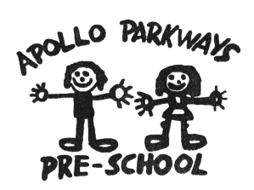

THREE-YEAR-OLD ENROLMENT APPLICATION FORM

Complete this enrolment application form and:
- Enclose a copy of the birth certificate or suitable evidence of the child’s birth date
- Enclose a copy of your child’s immunisation history
- Enclose the $10.00 application fee, which is not refundable, to cover administrative costs.
NO CASH PLEASE.
EFT accepted into the following bank account(please include a copy of the receipt with the enrolment application form):

Account name: Apollo Parkways Preschool
BSB: 633 000 (Bendigo Bank)
Account number: 175 035 930
Description: YOUR CHILD’S NAME
OR
A deposit form can be collected from the Kinder to deposit cash directly into our account.

-----------------------------------------------------------------------------------------------------------------------------------------
This application is for my child to attend in (please circle):2020 2021 2022
2 sessions per week (5 hours total)
Child’s family name: _________________________________________________________________

Given names: ______________________________________________________________________

Date of birth: _________/_________/________ Male  Female 

Parents’/guardians’ names: ___________________________________________________________

Address: __________________________________________________________________________

____________________________________________________________Postcode:____________

Telephone number: (Home) _________________________ (Business) _______________________
(Mobile) _________________________

Email: ____________________________________________________________________________

Language/s spoken at home: __________________________________________________________

Children with additional needs:
Does your child have additional needs Yes No 
If yes, please specify: ________________________________________________________________
You are encouraged to discuss your child’s needs with the teacher when your child’s place is confirmed.
Is your child registered with a specific agency? Yes  No 
Name of agency: ____________________________________________________________________
Signature of parent/guardian: __________________________________________________________

Date: __________________________

Forward the completed enrolment application form, with attachments, to:
The Enrolment Officer, Apollo Parkways Pre-School, 31 Plenty River Drive, Greensborough VIC 3088
- Please notify the centre of any changes to your address or other relevant information on: 9435 8752.

